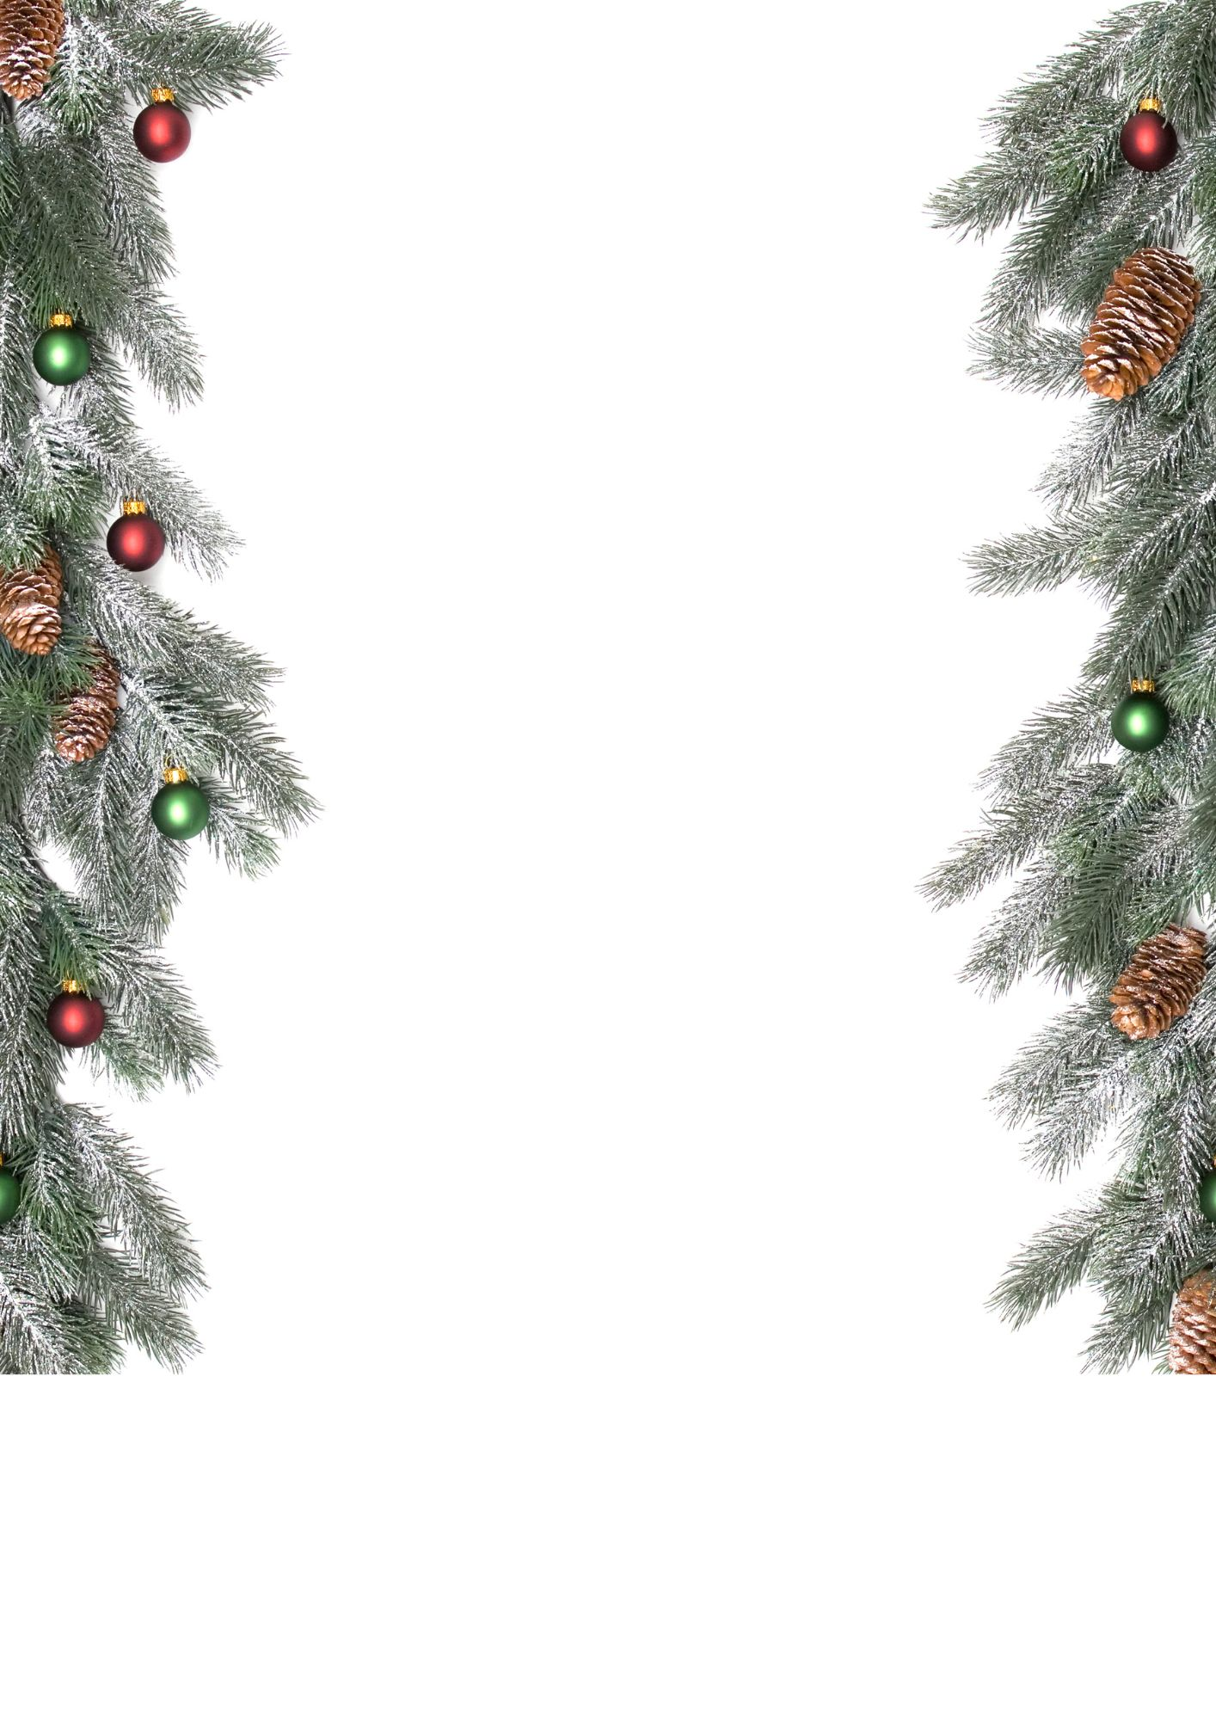

Dear Father Christmas,
I hope you, Mrs. Claus, and all the reindeer are doing well. How is Rudolph? I bet he’s keeping his nose extra shiny for the big night!
Thank you so much for the wonderful presents you brought me last year. I especially loved the Lego set and the books about space — I’ve learned so much about the planets! I’ve tried really hard to be good this year. I helped Mum with the dishes, shared my toys with my little sister (most of the time!), and did my homework without complaining (well, mostly).
This Christmas, if it’s not too much trouble, I would love:
- A new art set so I can draw more pictures for my friends and family
- A puzzle or a game we can all play together
- A book about dragons or magic
Please also remember to bring something nice for children who might not have much — I think they deserve some Christmas magic too.
We’ll leave some mince pies and a glass of milk for you, and a carrot for the reindeer. Have a safe journey around the world!
With love,
Emily (age 8)

